1. Transportation problem:

Cities 1 and 2 have 100K and 200K passengers per year, respectively. Airports 1 and 2 can accept a demand of 150K and 150K passengers per year, respectively. The city-to-airport driving times are listed at right.

Please formulate the linear programming problem and solve it using GAMS Solver.

Given:

$a(i)$: the demand of city $i$, $i∈\{1,2\}$

$b(j)$: the capacity of airport $j$, $j∈\{1,2\}$

$c\left(i,j\right)$: the driving time from city $i$ to airport $j$

To find:

$x(i,j)$: the passengers traveling from city $i$ to airport $j$

$z$: the total travel cost

Model:

$$\min{\sum_{i,j}{\{x(i,j)×c(i,j)\}}}$$

Subject to

$$\sum_{j}{x\left(i,j\right)=a\left(i\right), ∀i}$$

$$\sum_{i}{x\left(i,j\right)=b\left(j\right), ∀i}$$

$$x(i,j)≥0$$

Solutions from GAMS: $x\left(1,1\right)=100, x\left(2,1\right)=50, x\left(2,2\right)=150, and z=500$

GAMS Code:

|  |
| --- |
| $title Problem 2  *LIMROW = 0, LIMCOL = 0  OPTIONS ITERLIM=100000, RESLIM = 1000000, SYSOUT = OFF, SOLPRINT = OFF, lp = COINGLPK, mip = COINGLPK, OPTCR= 0.1;  Set i /1*2/;  alias (i, j);  parameter a(i)/  1 100  2 200  /;  parameter b(j)/  1 150  2 150  /;  parameter c(i,j)/  1. 1 1  1. 2 2  2. 1 2  2. 2 2  /;  variable z;  positive variables x(i,j);  equations  obj  demand(i)  supply(j)  ;  obj.. z =e= sum((i,j),c(i,j)*x(i,j));  demand(i).. sum(j,x(i,j)) =e= a(i);  supply(j).. sum(i,x(i,j)) =l= b(j);  Model problem_2 /all/;  solve problem_2 using LP minimizing z;  display x.l;  display z.l; |

2. Shortest path problem

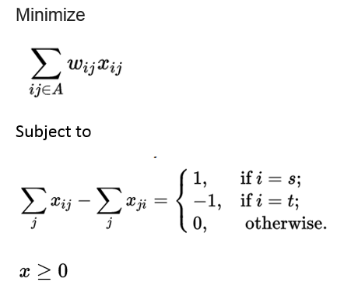 

3. Traffic assignment problem

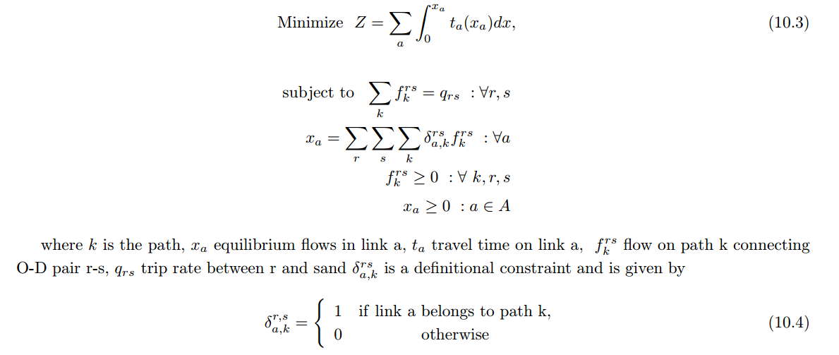

4. Dynamic system optimal problem

Space-time network:

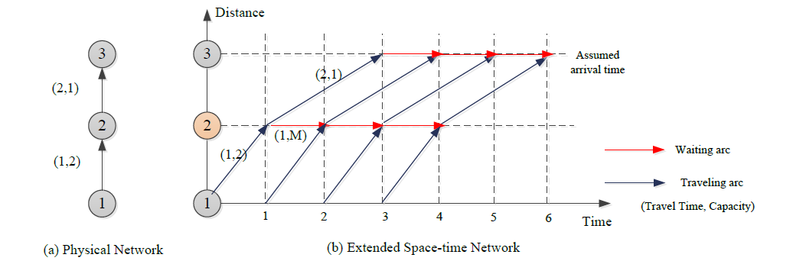

Agent-based model:

Minimize $Z=\sum_{f}{\sum_{(i,j,t,t')}{c_{i,j,t,t'}×x_{i,j,t,t'}^{f}}}$ (16)

Subject to

$\sum_{\left(i,j,t-t_{i,j},t\right)∈A}{x_{i,j,t-t_{i,j},t}^{f}}-\sum_{\left(j,k,t,t+t_{j,k}\right)∈A}{x_{j,k,t,t+s_{j,k}}^{f}}=\left\{\begin{matrix}-1 & ∀f∈F, j=O\left(f\right) and t=DT(f) \\ 1 & ∀f∈F,j=D\left(f\right) and t=T \\ 0 & otherwise\end{matrix}\right.$

$\sum_{f∈F}{x_{i,j,t,t+t_{i,j}}^{f}}≤{Cap}_{i,j}, ∀(i,j,t,t+t_{i,j})∈A,t=1,2,…,T$ (18)

$x_{i,j,t,t'}^{f}=\{0,1\}$

